Provider Certification Previous Volumes – Currently Certified ARCHIVE Data Entry Process

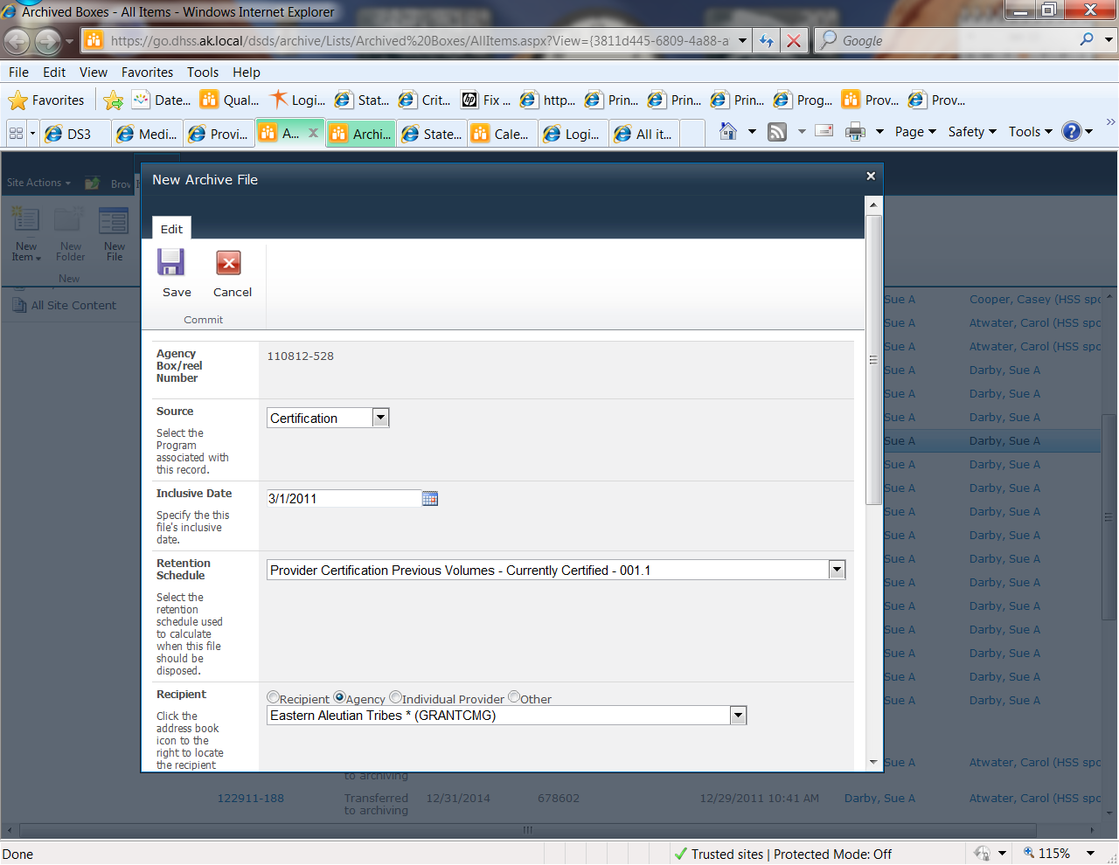

Agency Box is Automatically Assigned

Source is always Certification for QA files

Inclusive date is the previous cycles END Date

This is only for the OPEN providers to get extra hardcopy materials stored off site.

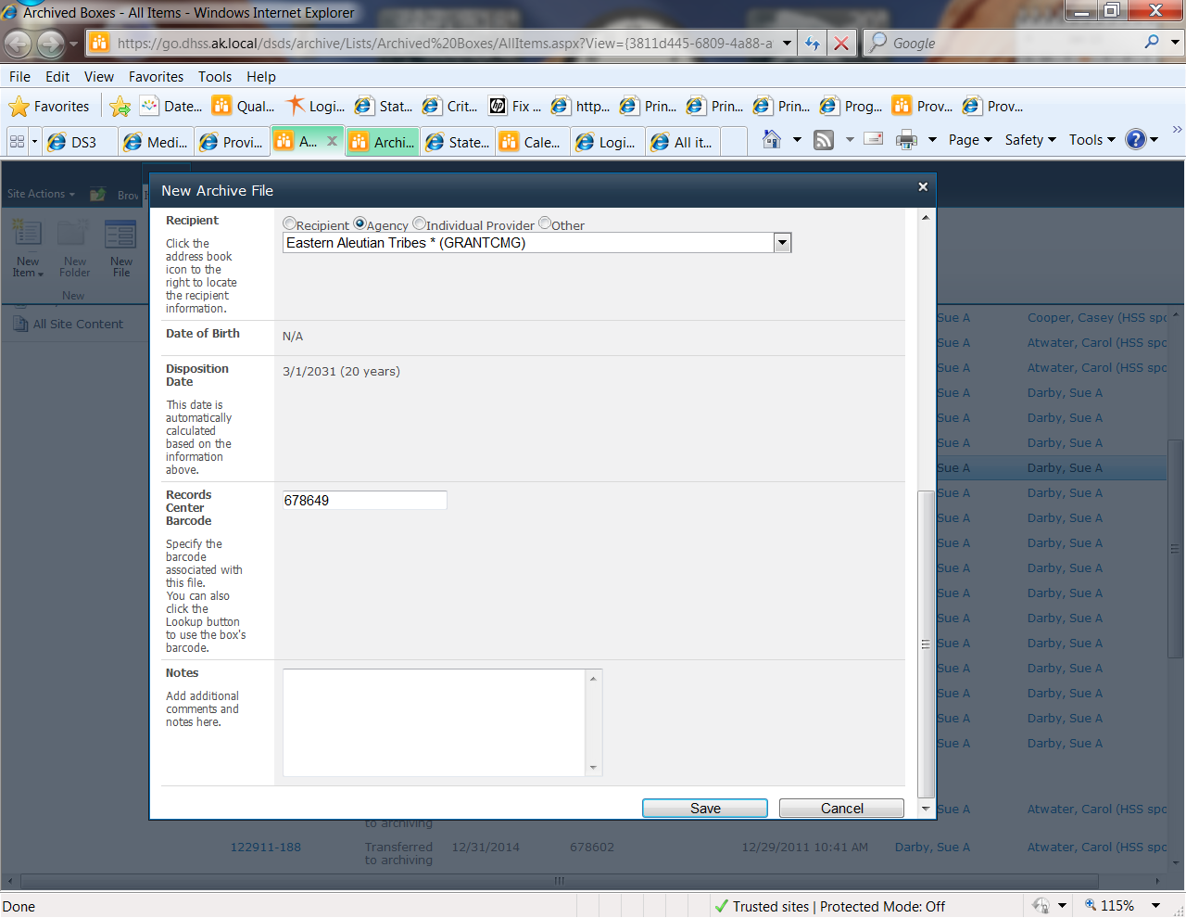

Choose a provider Agency

Be sure the provider numbers match!

Describes the contents of the file. I.E. Certification Materials for 2011-2013 Certification Cycle

Auto Filled based on the box chosen

Automatically calculated based on the Inclusive date (Certification Cycle End Date)

Hint: To make entering notes in DS3 more efficient for multiple entries per provider finish entering the box then download a report to Excel, filter to only show the box that was just finished, alphabetize and enter 1 note in DS3 for each provider noting the number of folders contained in the box and the contents from the Excel Report.

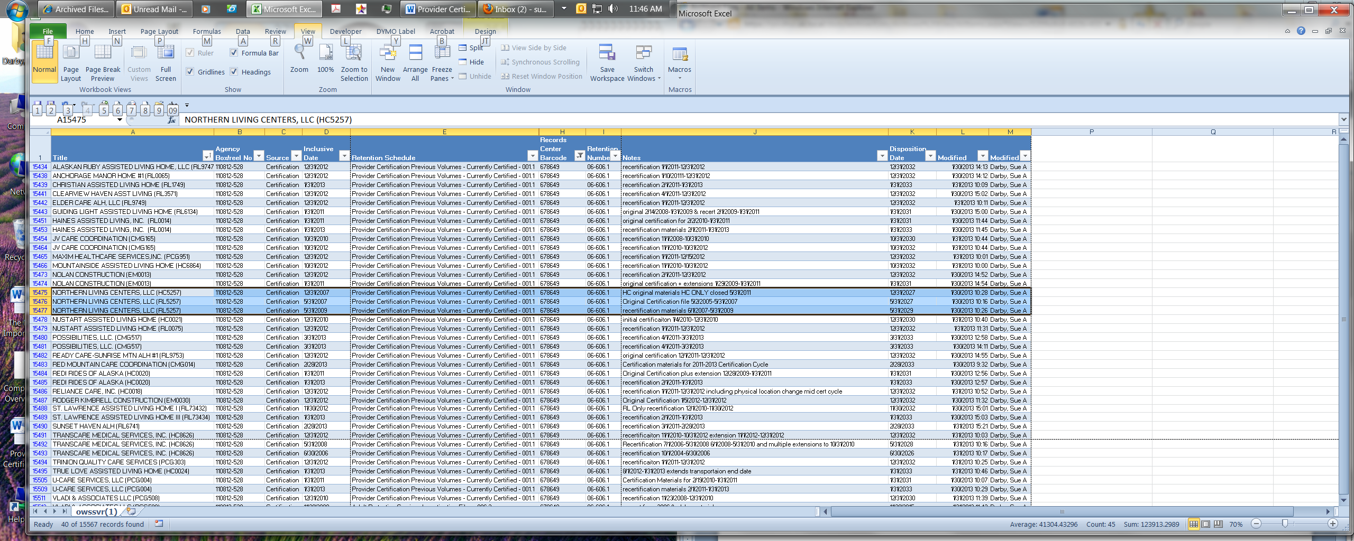

DS3 NOTES

Provider Record Location Note should have:

Agency Name:

Agency Box No:

Records Center Barcode:

Notes:

|  |  |  |  |
| --- | --- | --- | --- |
| **Title** | **Agency Box/reel No** | **Records Center Barcode** | **Notes** |
| ALASKAN RUBY ASSISTED LIVING HOME, LLC (RL9747) | 110812-528 | 678649 | recertification 1/1/2011-12/31/2012 |

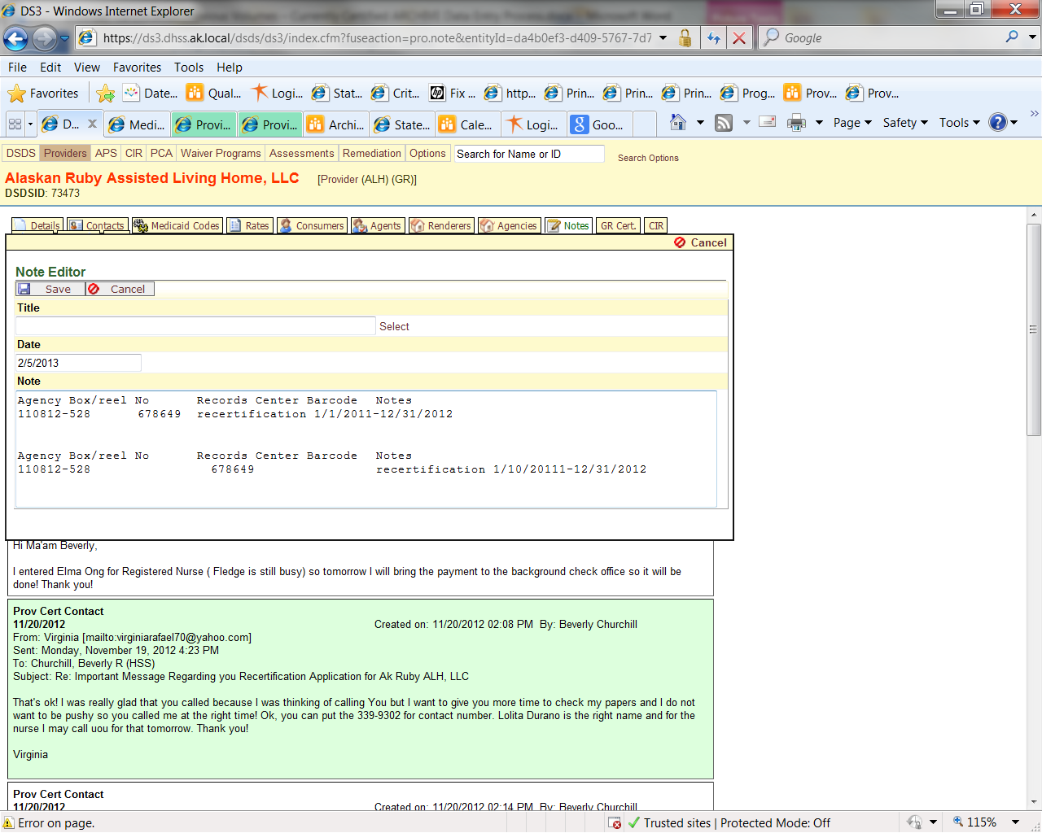

Use the spacebar to fix the alignment

Add additional folder entries to the same note

Final note should be number of folders in box

How it Copy/Pastes from Excel

Transferring to Archives

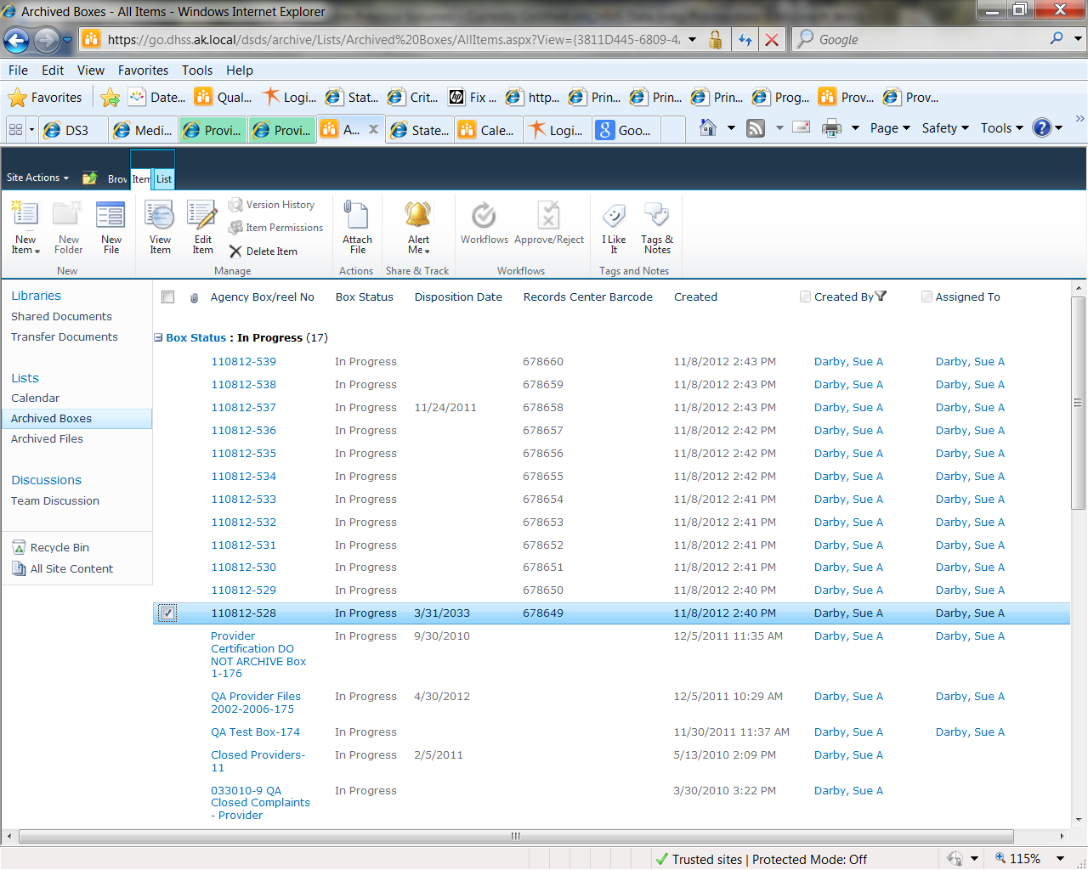

Choose a box to transfer

Go to Edit Item

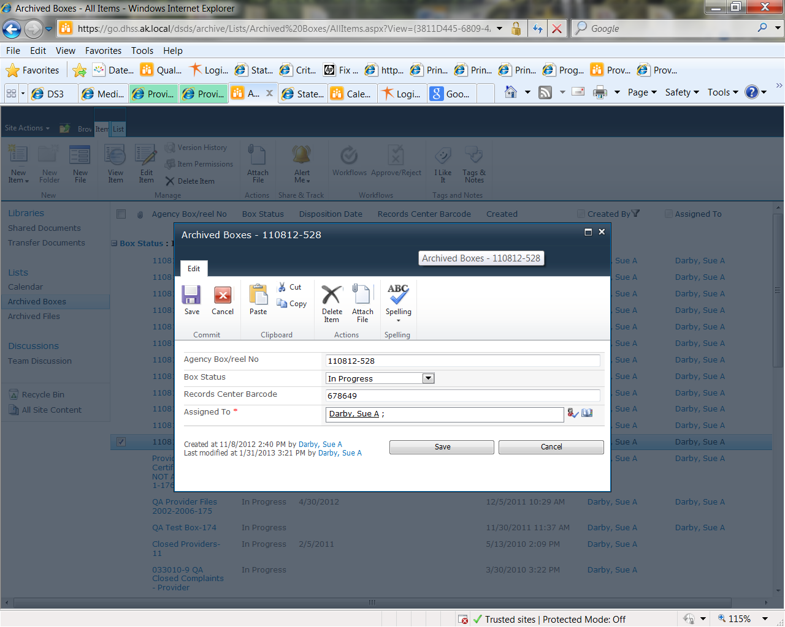

Change the box Status to “Ready to Be Archived”

Assign it to YOURSELF or you will not be able to generate the Report needed for Transfer!